**Database System Practical 8**

**Tables:**

**Sailors:** **Reserves:**

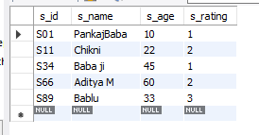 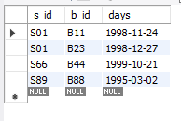

**Boats:**

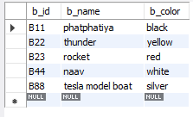

* **Using natural join:**

1. **Find names of sailors who have reserved boat number B11.**

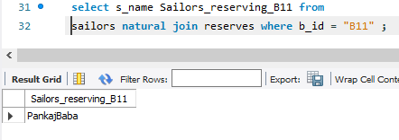

1. **Find names of sailors who have reserved at least one boat.**

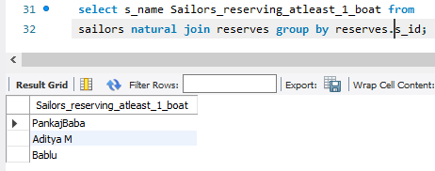

1. **Find names of sailors who have reserved a red boat.**

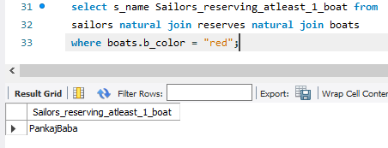

1. **Find the colors of boat reserved by Bablu.**

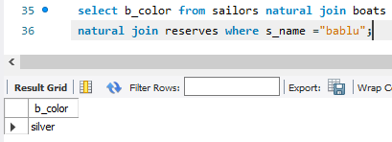

* **Using Equi join:**

1. **Find names of sailors who have reserved boat number B44**

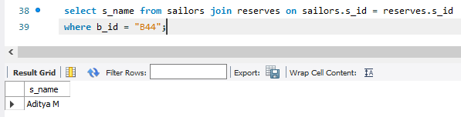

1. **Find names of sailors who have reserved at least one boat**

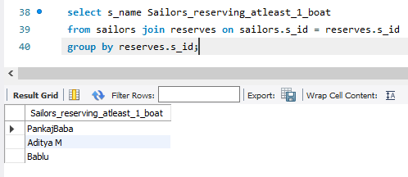

1. **Find names of sailors who have reserved a red boat**

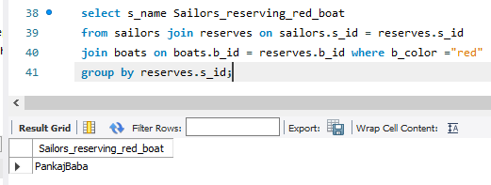

1. **Find the colors of boat reserved by Pankaj Baba**

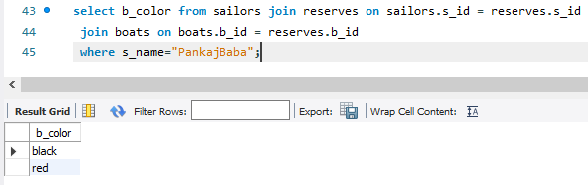

* **Self-join:**

1. **Create a table employee (emp_no, name, manager_no) where emp_no is the primary key and manager_no is the foreign key.**

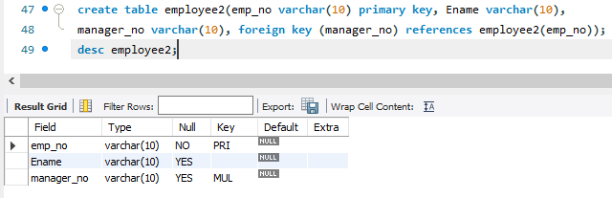

1. **Insert following rows:**

|  |  |  |
| --- | --- | --- |
| **emp_no** | **name** | **manager_no** |
| **e01** | **basu** | **e02** |
| **e02** | **rukmani** | **e05** |
| **e03** | **carol** | **e04** |
| **e04** | **bayross** | **null** |
| **e05** | **ivan** | **null** |

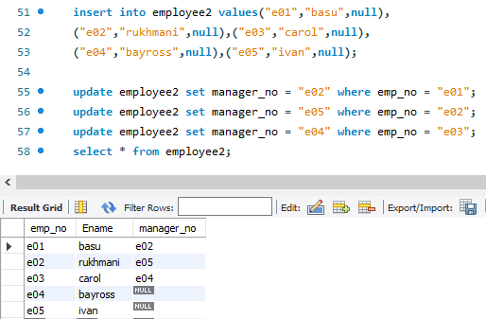

1. **Execute a query to retrieve names of the employees and the name of their respective managers from the employee table.**

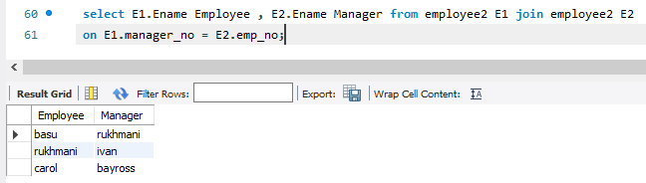

* **Outer join:**

1. **Create tables and insert these rows:**

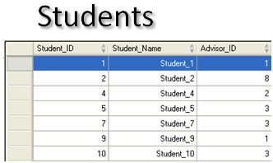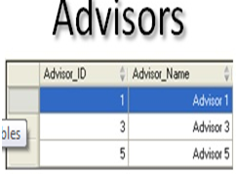

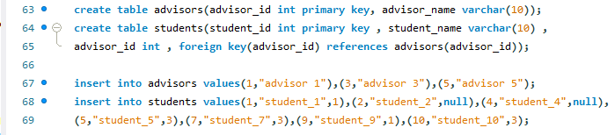

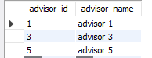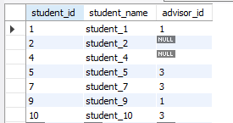

1. **Query for retrieving the student details along with their advisory detail**

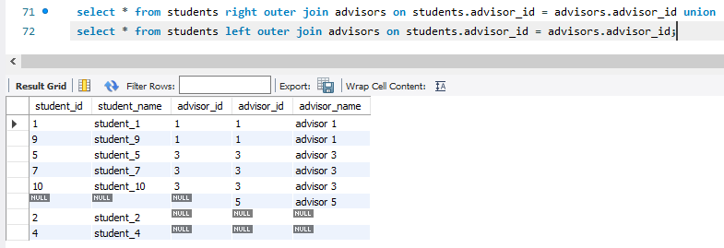

1. **Query for retrieving the details of all the student along with details of advisory (using outer join)**

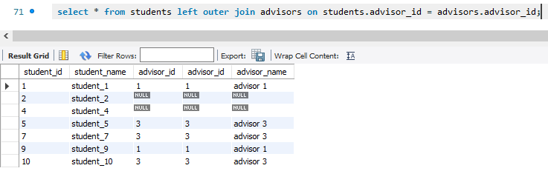

1. **Query for retrieving the details of student along with details of all the advisory (using outer join)**

